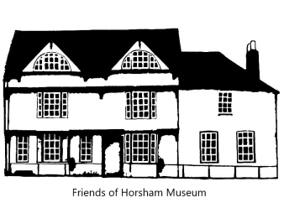
Friends of Horsham Museum & Art Gallery
Adopt an Artefact
Full Name
(Including title)
Address (incl. postcode)

Email address

Contact phone number

If this is a gift please supply the recipient's name and email address
Date of birth if under 16 years of age
Name on artefact label? | YES / NO
Name, as it should appear on the certificate
All above boxes must be completed.
Please send form to fhmadopt@gmail.com or to the museum.
I wish to adopt the following artefact
............................................................................................................

When you adopt your artefact you will receive a certificate confirming your adoption. Certificates will be emailed as a .pdf file unless specifically requested otherwise.
Bacs Payments: Sort code: 20-42-58 Account No: 90212660 Name: Friends of Horsham Museum
Ref: Adopt and add surname.
Adult adoption £15.00 per year or £40.00 for 3 years. Under 16s £5.00 per year or £12.00 for 3 years.
Make your donation go a little further at no extra cost to you.
Please read the declaration below, tick the box to make this a Gift Aid donation and we will be able to reclaim the tax.
I confirm that I am a UK taxpayer and understand that if I have paid less Income Tax and/or Capital Gains Tax than the amount of Gift Aid claimed on all my donations in that tax year, it is my responsibility to pay any difference.

Signed ..........................................................................................................................
Dated ...........................................................
Data Privacy Statement

Personal data is held and used in compliance with the General Data Protection Regulations. The Friends of Horsham Museum & Art Gallery hold your contact details only for the purpose of keeping you informed about matters relating to Horsham Museum.

These details will be kept for a maximum of 24 calendar months after your last active paid membership expires.

We will never share your personal or financial details with any other organisation.

Should you wish to request access, corrections or removal of your personal information please contact us by email or write to The Data Controller, The Friends of Horsham Museum & Art Gallery, 9 Causeway, Horsham RH12 1HE.

If you would prefer not to receive the email newsletter or other communication from the museum please tick here.

